DCC-GARCH correlation: GBPUSD and USDCHF
Method 09 / GARCH(1,1) + Engle DCC / Alpari D1 full available history

Study setup
Logical pair: GBPUSD , USDCHF
Broker symbols: GBPUSD_i , USDCHF_i
Snapshot: 2026-11-03_majors_alpari_D1
Timeframe: D1
Matched return window: 1999-01-05 to 2026-11-02 (UTC bar dates)
Matched return count n: 7201
Dropped unfinished last bar dated 2026-11-03 UTC after a tick-volume check against the prior complete day.
GBPUSD GARCH(1,1): mu=0.000021, omega=0.003995, alpha=0.055119, beta=0.932591
USDCHF GARCH(1,1): mu=-0.000354, omega=0.003266, alpha=0.042706, beta=0.955814
DCC: a=0.007399, b=0.991601, a+b=0.999000
Burn-in ignored in path summaries and chart: first 60 updates
Complete matched rows (Excel): GBPUSD-USDCHF_DCC_D1.xlsx
Complete matched rows (HTML table): GBPUSD-USDCHF_DCC_D1_data.html

Method carried forward
DCC-GARCH first fits a constant-mean GARCH(1,1) on each matched daily log return of close, ln(close_t / close_t-1), then updates Engle (2002) dynamic conditional correlation on the standardised shocks z = residual / conditional sigma. Quotes are not inverted. Correlation targeting sets Q_bar to the sample correlation of z; a and b are estimated by maximising the bivariate Gaussian DCC likelihood with a >= 0, b >= 0, and a + b < 1. Path summaries ignore the first 60 updates. The headline is rho on the last day. Same-sample Pearson r on log returns is a side check only. A high |rho| does not prove cause, lead-lag, or a trading signal.

Results
Latest DCC rho: -0.677422
Post-burn-in path (n=7141): mean=-0.537985, median=-0.539384, min=-0.822327, max=-0.098798, std=0.136128
Share of post-burn-in days with |rho| >= 0.4: 86.29%; |rho| >= 0.7: 13.28%
Same-sample Pearson r: -0.486083
Latest rho minus r: -0.191339

Conclusion
Over 7201 matched daily log-return rows for GBPUSD and USDCHF (broker quote directions unchanged), latest DCC rho is -0.6774 (negative, moderate conditional linear link in this sample) with fitted a=0.0074, b=0.9916 (a+b=0.9990). After a 60-day burn-in, path mean is -0.5380 and std is 0.1361. Same-sample Pearson r is -0.4861 (latest rho minus r = -0.1913). This does not establish cause, lead-lag, or a lasting trading rule.

Charts
Daily closes

Daily log returns
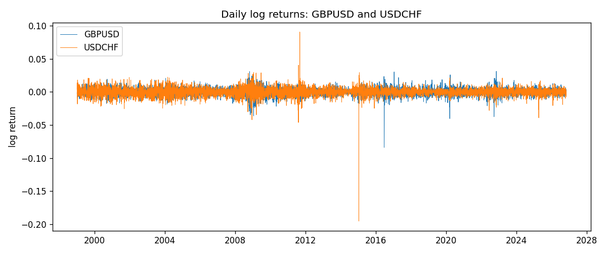
DCC rho path with Pearson r reference
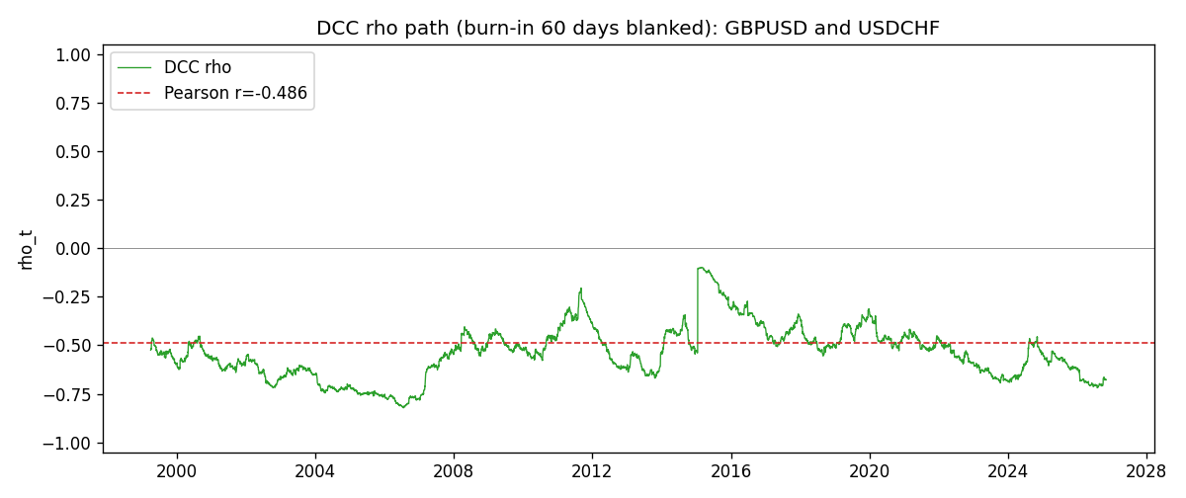

Data report
Every matched row that entered the DCC recursion is stored in the sibling Excel workbook named GBPUSD-USDCHF_DCC_D1.xlsx. Embedding all rows as a Word table is impractical at this length; the Word file holds the column list, column summaries, and the first and last 15 matched rows.
Columns: time, GBPUSD_open, USDCHF_open, GBPUSD_high, USDCHF_high, GBPUSD_low, USDCHF_low, GBPUSD_close, USDCHF_close, GBPUSD_tick_volume, USDCHF_tick_volume, GBPUSD_spread, USDCHF_spread, GBPUSD_real_volume, USDCHF_real_volume, GBPUSD_log_return, USDCHF_log_return, GBPUSD_sigma, USDCHF_sigma, GBPUSD_z, USDCHF_z, q11, q22, q12, rho_t
Column summaries (matched calculation rows)
column | count | mean | std | min | 25% | 50% | 75% | max
GBPUSD_open | 7201 | 1.5160785 | 0.218271 | 1.06854 | 1.32499 | 1.51142 | 1.63167 | 2.1066
USDCHF_open | 7201 | 1.0982956 | 0.25264095 | 0.72022 | 0.92069 | 0.99019 | 1.2387 | 1.8219
GBPUSD_high | 7201 | 1.5223771 | 0.21884011 | 1.08366 | 1.32979 | 1.5182 | 1.6384 | 2.1161
USDCHF_high | 7201 | 1.1035944 | 0.25438893 | 0.73305 | 0.92495 | 0.99377 | 1.2436 | 1.8313
GBPUSD_low | 7201 | 1.5097512 | 0.21749696 | 1.03518 | 1.31949 | 1.50336 | 1.6244 | 2.0983
USDCHF_low | 7201 | 1.0931703 | 0.25105533 | 0.08565 | 0.91742 | 0.9867 | 1.2331 | 1.8121
GBPUSD_close | 7201 | 1.5161456 | 0.2182303 | 1.06879 | 1.3251 | 1.5114 | 1.63212 | 2.1065
USDCHF_close | 7201 | 1.0982864 | 0.25254184 | 0.72025 | 0.92098 | 0.9902 | 1.2387 | 1.8217
GBPUSD_tick_volume | 7201 | 94828.085 | 153546.21 | 62 | 10002 | 52900 | 91806 | 1273370
USDCHF_tick_volume | 7201 | 74189.26 | 113409.95 | 18 | 12770 | 40195 | 70240 | 858589
GBPUSD_spread | 7201 | 26.971115 | 19.193539 | 0 | 11 | 20 | 50 | 50
USDCHF_spread | 7201 | 26.114567 | 24.723753 | 0 | 5 | 16 | 50 | 100
GBPUSD_real_volume | 7201 | 3.5560898e+09 | 8.4438214e+10 | 0 | 0 | 0 | 0 | 2.4038164e+12
USDCHF_real_volume | 7201 | 2.3236557e+10 | 8.9041498e+10 | 0 | 0 | 0 | 0 | 1.9331921e+12
GBPUSD_log_return | 7201 | -2.316e-05 | 0.00564524 | -0.08388241 | -0.00312969 | 3.242e-05 | 0.00318104 | 0.03112653
USDCHF_log_return | 7201 | -7.148e-05 | 0.00659332 | -0.19545699 | -0.00335964 | 8.06e-05 | 0.00331782 | 0.09051364
GBPUSD_sigma | 7201 | 0.00539712 | 0.00169157 | 0.00300411 | 0.0044801 | 0.00504063 | 0.00577094 | 0.0219492
USDCHF_sigma | 7201 | 0.00655186 | 0.0025883 | 0.00354625 | 0.00506186 | 0.0061083 | 0.00733966 | 0.04070609
GBPUSD_z | 7201 | -0.00702038 | 1.0000195 | -10.319789 | -0.60085909 | 0.00251205 | 0.60639205 | 4.9458385
USDCHF_z | 7201 | 0.04142072 | 0.99902916 | -34.238169 | -0.48191864 | 0.07224301 | 0.59885642 | 6.680756
q11 | 7201 | 1.0029988 | 0.11595618 | 0.69078916 | 0.9390207 | 0.99145118 | 1.0432502 | 1.9382506
q22 | 7201 | 1.00311 | 0.7535043 | 0.60991718 | 0.79995675 | 0.88374506 | 0.94986894 | 9.496848
q12 | 7201 | -0.50845221 | 0.11728659 | -0.81785197 | -0.5886737 | -0.50387769 | -0.42823871 | -0.22516655
rho_t | 7201 | -0.53786861 | 0.13556829 | -0.82232712 | -0.62709413 | -0.53797532 | -0.46088756 | -0.09879783
First 15 matched rows (selected columns)
time | GBPUSD_log_return | USDCHF_log_return | GBPUSD_sigma | USDCHF_sigma | GBPUSD_z | USDCHF_z | q11 | q22 | q12 | rho_t
1999-01-05 | -0.0028966287 | 0.0039424743 | 0.0040905601 | 0.0083887222 | -0.7132503 | 0.51213724 | 1 | 1 | -0.50922947 | -0.50922947
1999-01-06 | -0.00060452184 | 0.013605652 | 0.0040587476 | 0.0082689832 | -0.15410824 | 1.6881586 | 0.99636493 | 0.99454144 | -0.50816437 | -0.51048566
1999-01-07 | -0.002118709 | -0.0093883841 | 0.0039729116 | 0.0086025159 | -0.53856561 | -1.0502371 | 0.98917192 | 1.0082751 | -0.50633037 | -0.50700073
1999-01-08 | -0.0058954193 | 0.011040268 | 0.0039206985 | 0.0086339949 | -1.5090127 | 1.3196638 | 0.98400977 | 1.0089677 | -0.49840161 | -0.50019703
1999-01-11 | -0.0056851331 | 0.0052963193 | 0.004082222 | 0.0087819586 | -1.3977921 | 0.64336697 | 0.99359383 | 1.014379 | -0.50945946 | -0.5074638
1999-01-12 | 0.0022657001 | -0.0098275602 | 0.0042113354 | 0.0086836016 | 0.53302226 | -1.0910055 | 1.0007052 | 1.0099217 | -0.51234372 | -0.50964115
1999-01-13 | 0.0091330396 | -0.018259701 | 0.0041493433 | 0.0087311356 | 2.1960282 | -2.0508212 | 0.99540227 | 1.0112464 | -0.51285253 | -0.51116923
1999-01-14 | 0.0019376331 | -0.0024256692 | 0.0045861213 | 0.0093211346 | 0.417928 | -0.22228693 | 1.0237249 | 1.034873 | -0.54237799 | -0.52694695
1999-01-15 | -0.0017558204 | 0.01794228 | 0.004496299 | 0.0091408121 | -0.39516611 | 2.0015708 | 1.0174187 | 1.0275464 | -0.53901903 | -0.52717342
1999-01-18 | 0.0012112405 | -0.0031856384 | 0.0044076541 | 0.0097203233 | 0.27004747 | -0.29134171 | 1.0110286 | 1.0495594 | -0.54085337 | -0.52504232
1999-01-19 | 0.0018745281 | -7.2518946e-05 | 0.0043122397 | 0.0095382848 | 0.42983778 | 0.029479496 | 1.0040763 | 1.0423719 | -0.53740197 | -0.52529655
1999-01-20 | -0.0049053846 | 0.0072259871 | 0.0042344746 | 0.0093428505 | -1.1633909 | 0.81128237 | 0.99800988 | 1.0346231 | -0.53330365 | -0.52482685
1999-01-21 | 0.0031518998 | -0.0038232689 | 0.0042964235 | 0.0092850441 | 0.72873059 | -0.37367255 | 1.0006421 | 1.0318031 | -0.53631724 | -0.52781771
1999-01-22 | 0.0024781662 | -0.0001445609 | 0.0042608385 | 0.00912378 | 0.57669439 | 0.022922723 | 0.99716678 | 1.0251699 | -0.53433666 | -0.52848559
1999-01-25 | 0.0012066366 | 0.0024546976 | 0.0042027659 | 0.0089383237 | 0.28211708 | 0.31419766 | 0.99225213 | 1.0175631 | -0.53026004 | -0.52771229
Last 15 matched rows (selected columns)
time | GBPUSD_log_return | USDCHF_log_return | GBPUSD_sigma | USDCHF_sigma | GBPUSD_z | USDCHF_z | q11 | q22 | q12 | rho_t
2026-10-13 | 0.0036434319 | -0.0024955621 | 0.003670254 | 0.004740199 | 0.98697999 | -0.45185008 | 0.82343332 | 0.78828334 | -0.53611375 | -0.66542874
2026-10-14 | -0.0049164679 | 0.0029388325 | 0.0036993908 | 0.0046903241 | -1.334661 | 0.70198459 | 0.82472493 | 0.78417303 | -0.53541985 | -0.66578492
2026-10-15 | 0.0065976411 | -0.0097855323 | 0.0038086962 | 0.0046708273 | 1.7267527 | -2.019306 | 0.83197831 | 0.78223278 | -0.5383644 | -0.66734794
2026-10-16 | 0.0037592051 | -0.0036230826 | 0.0040387953 | 0.004997832 | 0.92558306 | -0.6541596 | 0.84805253 | 0.80683384 | -0.56015186 | -0.67717724
2026-10-19 | -0.0017500314 | 0.0036351779 | 0.0040474746 | 0.0049656506 | -0.43755581 | 0.80329468 | 0.84826849 | 0.80422336 | -0.56043632 | -0.67853346
2026-10-20 | 0.0055923442 | -0.0026281224 | 0.0039812207 | 0.0049572412 | 1.3994149 | -0.45880754 | 0.84356028 | 0.80324308 | -0.55883904 | -0.67889901
2026-10-21 | 0.0012476328 | -0.00040027413 | 0.0041099982 | 0.0049026416 | 0.29845956 | -0.0094992368 | 0.85196544 | 0.79905401 | -0.55940522 | -0.67799651
2026-10-22 | 0.00022396082 | -0.0048036381 | 0.0040293713 | 0.0048270603 | 0.050379133 | -0.92187275 | 0.84646866 | 0.7933432 | -0.55523683 | -0.67755144
2026-10-23 | -0.0021146949 | 0.005652514 | 0.0039424803 | 0.004841817 | -0.54170454 | 1.2404882 | 0.84037772 | 0.79396796 | -0.55142612 | -0.67506964
2026-10-26 | -0.0024340661 | 0.0018407959 | 0.0038918238 | 0.0049269172 | -0.63081755 | 0.4454101 | 0.83649043 | 0.79968529 | -0.55227592 | -0.67525229
2026-10-27 | -0.0023648393 | 0.0026100526 | 0.0038544776 | 0.0048717716 | -0.61896947 | 0.60835269 | 0.83340892 | 0.79543646 | -0.55022542 | -0.67578545
2026-10-28 | 0.0015771808 | -0.0010142111 | 0.0038169009 | 0.0048360251 | 0.40771722 | -0.13658083 | 0.83024372 | 0.79249379 | -0.54889937 | -0.67669349
2026-10-29 | 0.0035881935 | -0.0048680164 | 0.0037576115 | 0.0047643425 | 0.94933415 | -0.9475208 | 0.82550029 | 0.78697545 | -0.54521028 | -0.67643307
2026-10-30 | 0.0013450605 | 0.00071594559 | 0.0037773987 | 0.004784649 | 0.35053114 | 0.22355838 | 0.82623517 | 0.78800846 | -0.54779589 | -0.67889325
2026-11-02 | 0.0010971256 | -0.0071459744 | 0.0037152421 | 0.0047177068 | 0.28966106 | -1.4397401 | 0.82120456 | 0.78275957 | -0.54312419 | -0.67742198

